1. **Case (100%)**

A restaurant owner is planning to computerize their business. This restaurant provides dine-in, take-away and delivery services. The restaurant owner needs to have monthly reports on how the restaurant performs (sales reports).

The restaurant owner has asked you to develop the system. You (as the scrum master) brought your team to work on this application.

Below are the results from the sprint planning activity: Note that the number inside the brackets shows the task number.

The following shows the daily plan for the sprint:

These are the conversation of the daily scrum meeting.

The development went according to schedule, with the exception of the following tasks:

* Day 2 Dewey has a slight delay in task 6. The delay was for 1 hour.
* Day 3 Minnie (task 4) an Louie task 3) have completed their tasks.
* Day 5 Donald encountered problem, a delay of 1 hour, therefore the estimated completion is 6 hours. Huey also has a delay of 1 hour in task 8.
* Day 9 Huey and Mickey encountered problems in task 14 and task 18 respectively. A delay of 4 hours for Huey and delay of 3 hours for Mickey.
* Day 10 everyone manages to catch up except for Huey. He still needs 14 hours to complete his work.
* Day 11 finally Huey caught up a little. At this point he needs 8 hours to complete task 14. Donald has completed task 17.
* Day 12 Huey needs 6 hours to complete task 14.
* Day 13 Huey needs 3 hours to complete task 14.
* Day 14 everyone has completed their tasks.

1. **Question 1. [20%] Sprint Planning**

**Suppose you want to make this system in 2 sprints. How would you plan the tasks, (considering the features are the same)? Remember that after each sprint, most likely there will be releases.**

**Answer:**

* **Sprint 1 ( 7 days)**
* **Sprint Planning Activity**

|  |  |  |  |  |  |
| --- | --- | --- | --- | --- | --- |
| **Menu Preparation** | **UI (1)** | **Database Preparation (2)** | **CRUD Menu (3)** | **Testing (4)** |  |
|  |
| **Donald** | **Mickey** | **Louie** | **Daisy** |  |
| **10 hrs** | **15 hrs** | **15 hrs** | **10 hrs** |  |
| **Food Order** | **UI (5)** | **Dine in (6)** | **Take Away (7)** | **Delivery Service (8)** | **Testing (9)** |
|  |
| **Minnie** | **Dewey** | **Mickey** | **Huey** | **Daisy** |  |
| **15 hrs** | **15 hrs** | **15 hrs** | **10 hrs** | **10 Hrs** |  |
| **Payment** | **UI (10)** | **Process Payment (11)** | **Prepare for delivery (12)** | **Testing (13)** |  |  |
|  |  |
| **Donald** | **Huey** | **Huey** | **Daisy** |  |  |
| **15 hrs** | **15 hrs** | **13 hrs** | **10 hrs** |  |  |

* **Daily Plan for the Sprint**

|  |  |  |  |  |  |  |  |
| --- | --- | --- | --- | --- | --- | --- | --- |
| Task | Day 1 | Day 2 | Day 3 | Day 4 | Day 5 | Day 6 | Day 7 |
| Donald (1) | 10 | 5 | 0 | 0 | 0 | 0 | 0 |
| Mickey (2) | 15 | 10 | 5 | 0 | 0 | 0 | 0 |
| Louie (3) | 15 | 10 | 5 | 0 | 0 | 0 | 0 |
| Daisy (4) | 10 | 5 | 0 | 0 | 0 | 0 | 0 |
| Minnie (5) | 15 | 10 | 5 | 0 | 0 | 0 | 0 |
| Dewey (6) | 15 | 10 | 5 | 0 | 0 | 0 | 0 |
| Mickey (7) | 15 | 15 | 15 | 15 | 10 | 5 | 0 |
| Huey (8) | 10 | 5 | 0 | 0 | 0 | 0 | 0 |
| Daisy (9) | 10 | 10 | 10 | 5 | 0 | 0 | 0 |
| Donald (10) | 15 | 15 | 15 | 10 | 5 | 0 | 0 |
| Louie (11) | 15 | 15 | 15 | 15 | 10 | 5 | 0 |
| Huey (12) | 13 | 13 | 13 | 8 | 3 | 0 | 0 |
| Daisy (13) | 10 | 10 | 10 | 10 | 10 | 5 | 0 |
| Total | 168 | 133 | 98 | 63 | 38 | 15 | 0 |

* **Sprint 2 (7 days)**
* **Sprint Planning Activity**

|  |  |  |  |
| --- | --- | --- | --- |
| **Login** | **UI (1)** | **Password Validation (2)** | **Testing(3)** |
|  |
| **Donald** | **Minnie** | **Huey** |  |
| **2 hrs** | **15 hrs** | **3 hrs** |  |
| **Reporting** | **UI (4)** | **Reports (5)** | **Testing (6)** |  |
|  |
| **Donald** | **Dewey** | **Huey** |  |
| **3 hrs** | **15 hrs** | **4 hrs** |  |

* **Daily Plan for the Sprint**

|  |  |  |  |  |  |  |  |
| --- | --- | --- | --- | --- | --- | --- | --- |
| Task | Day 1 | Day 2 | Day 3 | Day 4 | Day 5 | Day 6 | Day 7 |
| Donald (1) | 2 | 1 | 0 | 0 | 0 | 0 | 0 |
| Minnie (2) | 15 | 12 | 9 | 6 | 3 | 1 | 0 |
| Huey (3) | 3 | 1 | 0 | 0 | 0 | 0 | 0 |
| Donald (4) | 3 | 3 | 3 | 2 | 1 | 0 | 0 |
| Dewey (5) | 15 | 12 | 9 | 6 | 3 | 1 | 0 |
| Huey (6) | 4 | 4 | 4 | 3 | 2 | 1 | 0 |
| Total | 42 | 33 | 25 | 17 | 9 | 3 | 0 |

1. **Question 2. [20%] Sprint Release**

**Prepare the activities that you require for release after the end of the sprint.**

**Answer:**

1. **Fixed Date**

* The highest priority features are being developed and completed first, any features that don’t make it into the first release are less valuable, which makes it easier to release the product as scheduled.

1. **Updating Constraints**

* Revisit the constraints to see if they should be rebalanced in light of the realities of the development effort. These must be continuously do during a Scrum development effort.

1. **Refine Minimum Releasable Features**

* To reevaluate and refine the Minimum Releasable Features to only include those that are truly necessary, based on the fast feedback and validated learning acquired during sprints.

1. **Sprint Mapping**

* Give a rough idea of when certain features within the release will be created.
* Give insight into how to structure the product backlog in more natural or efficient ways.
* Allow visibility into inter-team dependencies. Facilitate rolling, look-ahead planning activities.

1. **Communicating with Team**

* Can be done using Burn Up Chart, by shows the total amount of work in a release as a total or target line, and the progress each sprint toward achieving that goal. As the sprints progress, can see at a glance which of have been delivered, which remain, and where the will have and might have lines are trending based on the team’s actual velocity.

1. **Question 3. [20%] Sprint Execution**

**Prepare the burnt down chart for the planned and actual sprint.**

**Answer:**

* **Planned Sprint**

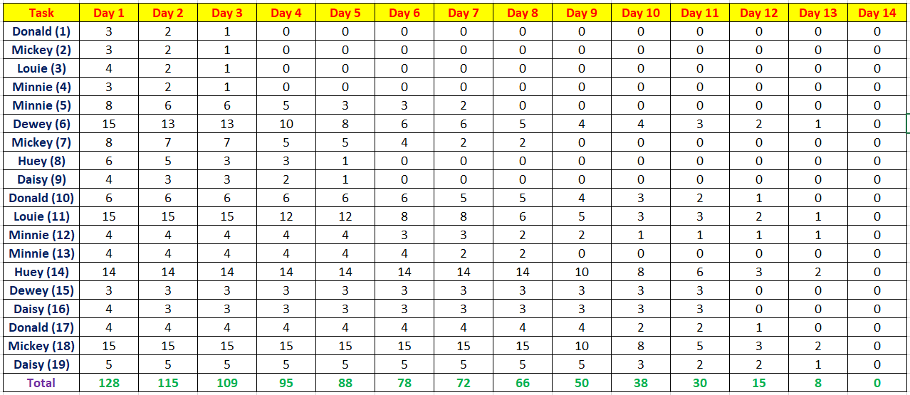

* **Actual Sprint**

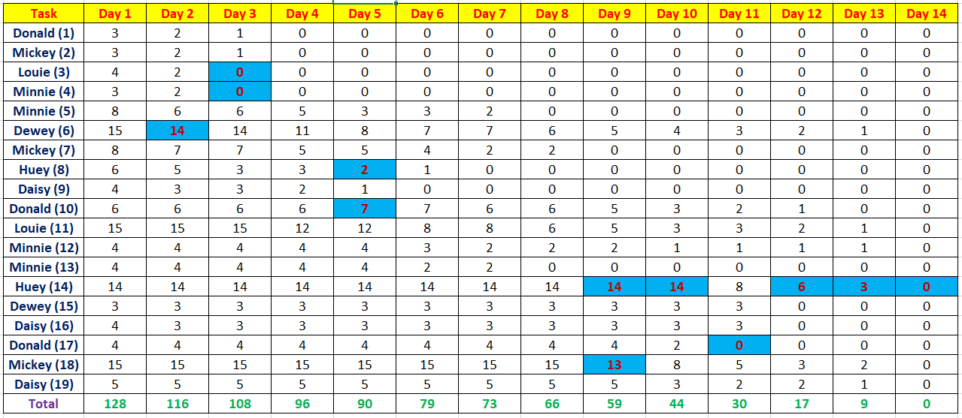

1. **Question 4. [20%] Sprint Review**

**You have noticed some delay occurs during the sprint execution. What are the possible causes of the delay, especially in the case of Huey, where the delay was quite large. How can you anticipate these problems in future?**

**Answer:**

1. **Expansion of Functionality**

* New functionalities continue to be conceived and requested as the project proceeds. The software can never be completed in this way.

**Anticipation:** Signed the Memorandum of Understanding (MoU) and Memorandum of Agreement (MoA) between Stakeholders, Project Manager, and the Team.

1. **Overly Optimistic Schedules**

* Pressure on the project team because of the (unrealistic) deadlines. These attempts lead to sloppy work and more errors, which cause further delays.

**Anticipation:** Complete a project (more) quickly sometimes arises for primarily strategic reasons. If it is not feasible, however, it should not be attempted.

1. **Customers Fail to Fulfil Agreements**

* When customers do not react in a timely manner to areas in which they must be involved, projects can come to a standstill.

**Anticipation:** Give warnings max. 3 times to customer. If Fail the Agreement again, charge more money for the project or no accept other project from that customer again.

1. **Tension between Customers and Developers**

* Because the project is not proceeding quickly enough as it disturbs the necessary base of trust and the working atmosphere.

**Anticipation:** Because User involve in the Sprint, user must know detailed so the misunderstanding can be reduced.

1. **Mediocre Personnel**

* Insufficiently qualified personnel can cause project delays as do knowledge and skills in working together to play the game of the project.

**Anticipation:** Signed the Memorandum of Understanding (MoU) and Memorandum of Agreement (MoA) between Stakeholders, Project Manager, and the Team.

1. **Question 5. [20%] Sprint Retrospective**

**You need to identify insights in the following category: what worked well, what didn’t work well and what are the opportunity to do things differently. Identify 5 insights for each category.**

**Answer:**

* **Worked Well**
* **Minnie** has done a very good job in User Interface functions requirement. From 2 tasks, all of them done completely without any delay.
* **Donald** has done a very good job in User Interface functions requirement. From 3 tasks, only 1 times delay and only 1 hour of delay.
* **Daisy** has done a very good job in Testing functions requirement. From 3 tasks, all of them done completely without any delay.
* **Dewey** has done a very good job in Dine in Function and Prepare for Delivery Function, with only 1 hour of delay in Dine in.
* **Louie** has done a very good job in Password Validation and CRUD Menu, all tasks done with no delay.
* **Didn’t Work Well**
* **Huey** is not very good at doing his job in Process Payment functions requirement, because there is a lot of delay happened on that task.
* Not divided into several sprints, but 1 sprint run over 2 weeks, it is to Overly Optimistic Schedules.
* There is some task that the person who work on that task had less knowledge and skills in that task.
* There is a contradiction on the Planned Sprint, where Testing done first before the other task completed. For example in task 9.
* The lack of people to do on this project is because the time each task is made is very small, causing a lot of delay.
* **Opportunity to do Things Differently**
* Task 8 (Delivery Service) and Task 15 (Prepare for Delivery can be built in one functions requirements.
* Task 6 (Dine in) and Task 7 (Take Away) can be done in one step of requirements, because it is same as buying food/drink.
* Make Sprint Planning more flexible by doing it in 2 or more Sprint.
* This Project can be done using with Swarming Techniques.
* Recruit more people if still want to do it in 2 weeks or the hours each task can be extended.